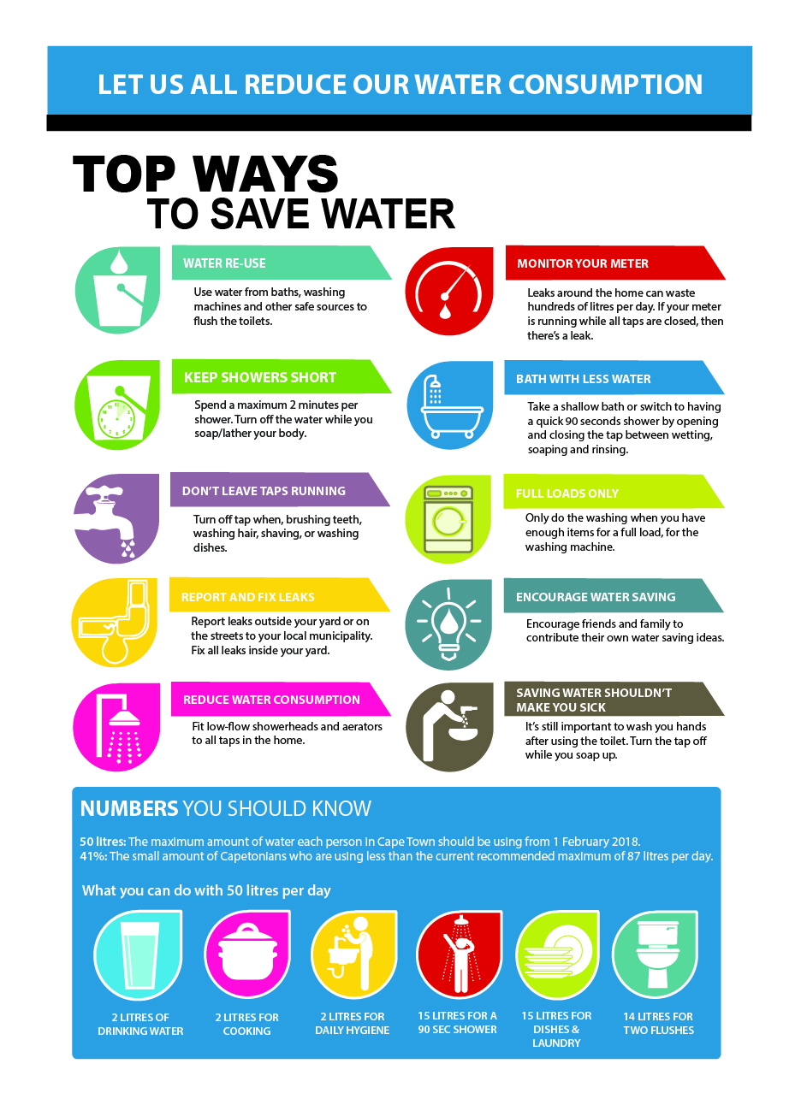­

**LOGO**

**LOGO**

**LOGO**

**LOGO**

**LOGO**

